AI FitTrack Project Planning
  - Phase 4

This plan organizes the completed backend work into dependency-based gates and records the confirmed four-person team structure, academic details, and confirmed responsibilities.
Field | Value
Project | AI FitTrack
Submission | SmartBridge Naan Mudhalvan
Team ID | SWTID-2026-8100
Team size | 4
College | DRBCCC Hindu College
Department | B.Sc. Computer Science with Artificial Intelligence
Academic Year | 2024–2027
Faculty Guide | Prof. D Saraswathy
Submission Date
Team Leader | Parthiban M (NM ID: 28538B1DB05060E8D804CDAA88169909, Reg: 222401226)
Team Members | Naveen J (NM ID: 53C2DC1753C6DFDAF8649841B4630C80, Reg: 222401223); Nidesh N S (NM ID: FDE55A8DA9135F6AB7347C01AD1B8A17, Reg: 222401224); Nithish Kumar P (NM ID: BFBD9AD8CEC72229F374877DB82CC0B8, Reg: 222401225)
Project scope | Backend-only REST API
Technology | Node.js, Express.js, MongoDB, Mongoose, JWT and Google Gemini AI
Source baseline | Latest uploaded backend ZIP and supplied verification evidence
Document status | Submission-ready verified technical documentation with complete academic details

Prepared for academic evaluation. Secrets, credentials, private environment files and unverified claims are excluded.

Document contents
1. Planning approach
2. Work breakdown
3. Deliverables
4. Dependencies
5. Quality and risk plan
6. Roles and submission gates

Planning approach
This plan organizes the project using ordered completion gates with measurable outputs and acceptance conditions. The confirmed team roster, academic details, and confirmed responsibilities are recorded below.
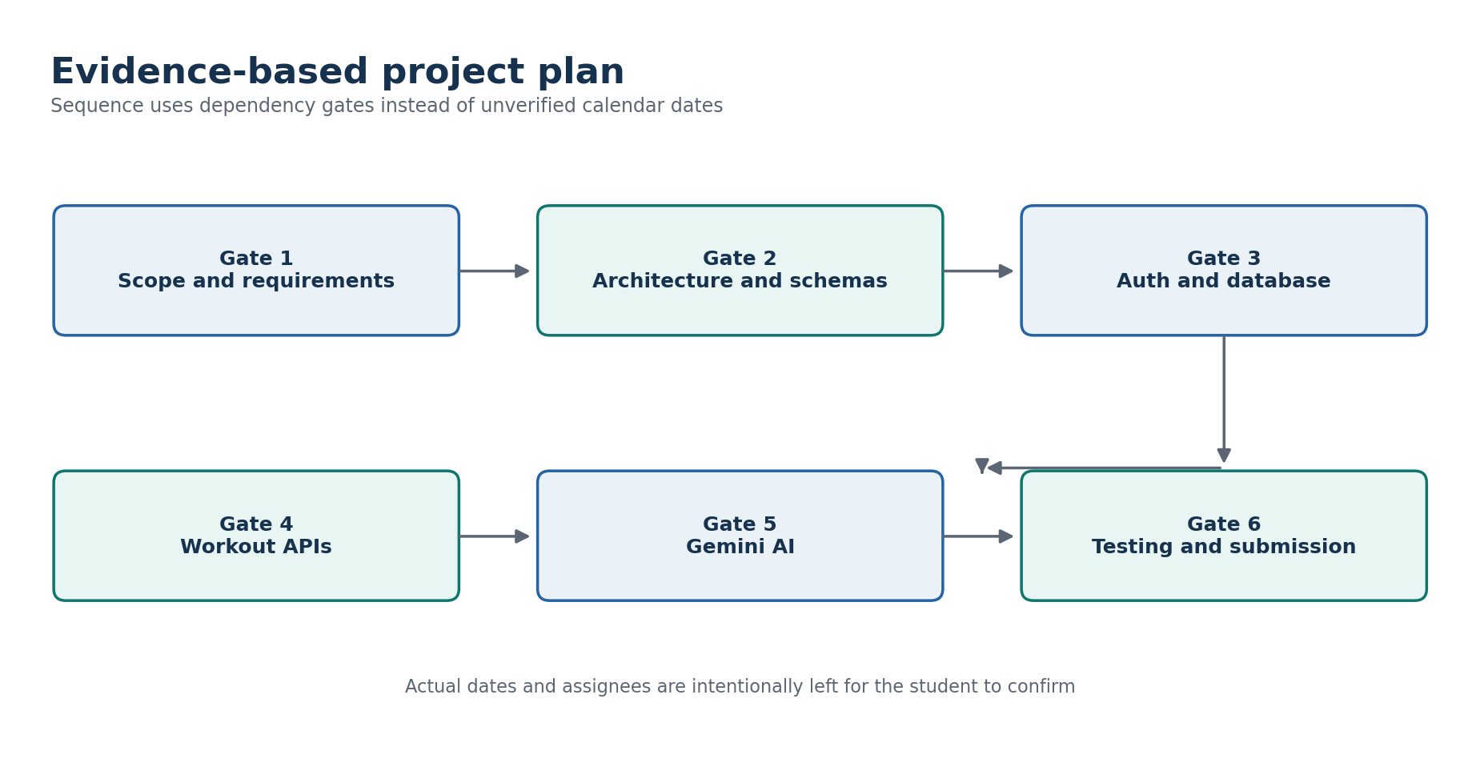
Figure 1 Dependency-based project gates without unverified dates

Work breakdown structure
Gate | Work package | Deliverable | Acceptance evidence
1 | Scope and requirements | Problem statement, objectives, actor and requirement list | Official document mapped to 24 backend requirements
2 | Architecture and data | Layer design, API design, User and Workout schemas | Source folders, schema constraints and diagrams agree
3 | Authentication and database | MongoDB connection, User model, bcrypt, JWT, profile | Registration, login, profile and unauthorized evidence
4 | Workout module | CRUD, search, validation and ownership | Eight live workout records plus automated tests
5 | Gemini AI module | Recommendation, submitted insights and database insights | Three live sanitized Gemini response records
6 | Verification and submission | Tests, documentation, repository and demonstration | 95 automated passes recorded; final links still pending

Planned deliverables
- Backend source with dependency lockfile and safe .env.example.
- Postman collection containing health, authentication, workout and AI requests.
- Automated tests for authentication, workouts, validation, security and Gemini retry behavior.
- Sanitized live verification records with no passwords, tokens, database credentials or API keys.
- Eight-phase DOCX and PDF documentation set.
- Public GitHub repository and student-recorded demonstration video after final upload.

Dependency plan
Dependency | Needed by | Control
Node.js 20+ and npm | All development and tests | Use engines declaration and package-lock.json.
MongoDB | Auth and workout persistence | Connect before server listen; fail with actionable error.
JWT secret | Registration, login and protected routes | Fail at startup if absent; recommend at least 32 characters.
Gemini API key | AI recommendation and insights | Return safe 503 when absent; do not expose the key.
Network access | Atlas and Gemini live checks | Use local mocked tests when external services are unavailable.
Postman or HTTP client | Demonstration and manual verification | Run the collection in the documented order.

Risk register
Risk | Likelihood | Impact | Implemented or planned response
Credential exposure | Medium | High | Commit only .env.example; hide terminal and Postman environment values during recording.
Atlas connection failure | Medium | High | Configurable DNS, IPv4 option, timeout and clear startup failure.
Gemini quota or downtime | Medium | Medium | Bounded retries, timeout, rate limit and safe normalized errors.
Cross-user data access | Low | High | JWT user reload and owner-scoped queries; automated isolation tests.
Invalid client input | Medium | Medium | Controller validation plus Mongoose validation and standard 400 responses.
Evidence mismatch after code change | Medium | Medium | Re-run Postman evidence after the final ZIP is frozen.
Missing submission identity or URLs | High | Medium | Complete the pending metadata checklist before upload.

Quality plan
- Review requirement-to-source traceability before declaring completion.
- Keep password, token and API-key values out of evidence and documentation.
- Run automated tests, smoke checks, Atlas checks and live Gemini checks on the frozen release.
- Verify response envelopes and status codes in Postman.
- Inspect DOCX and PDF output for clipping, unreadable tables and missing figures.
- Confirm the public repository excludes node_modules and every private .env file.

Team roster and responsibility status
Team member | Supplied designation | Confirmed responsibility
Parthiban M | Team Leader | Project architecture, complete backend development, MongoDB integration, Gemini AI implementation and final delivery.
Naveen J | Team Member | Reviewing requirements, organizing the eight-phase documentation and checking submission guidelines.
Nidesh N S | Team Member | Reviewing Postman API test results, checking test evidence and helping verify that the APIs meet the requirements.
Nithish Kumar P | Team Member | Reviewing the final report, helping prepare the demonstration and organizing GitHub and SkillWallet submission materials.

The confirmed responsibilities of each team member are listed in the team roster below.

Items requiring student confirmation
Pending item | What to provide
Repository | Insert the final public GitHub repository URL after upload.
Deployment | Insert the deployed API base URL if the evaluator requires a hosted demonstration.
Demonstration video | Record the video using Phase 8 and insert the final shareable video URL.

